**Lesson 12**

**1) What are the following BS numbers also known as?**

**BS 60898 - MCB**

**2) Name 2 pros and cons for PVC conduit, metal trunking and cable tray ?**

**Pros**

**PVC - Cheap and easy to work with.**

**Metal - Strong and provide good levels of protection**

**Cons**

**PVC - easily damaged.**

**Metal - requires more time and skill to mould**

**Cable tray is open to air so cables cool down more quickly. Whereas, wire in a conduit will heat up quicker. Hence, cable in a conduit will have to be larger.**

**3) What is the R1 + R2 of 42mm of 2.5mm line & 1.5mm cpc cable?**

**0.98Ω**

**Page 218 on table I1 look at row with Copper Value of 19.51**

**(R1 + R2) X L X C**

**19.51 x 42 x 1.2 / 1000 = 0.98Ω**

**C => stands for correction factor and it is on page 220 on table I3.**

**4) If my Ze is 0.08Ω what is my Zs?**

**Zs = Ze + (R1 + R2) =>**

**0.08 + 0.098**

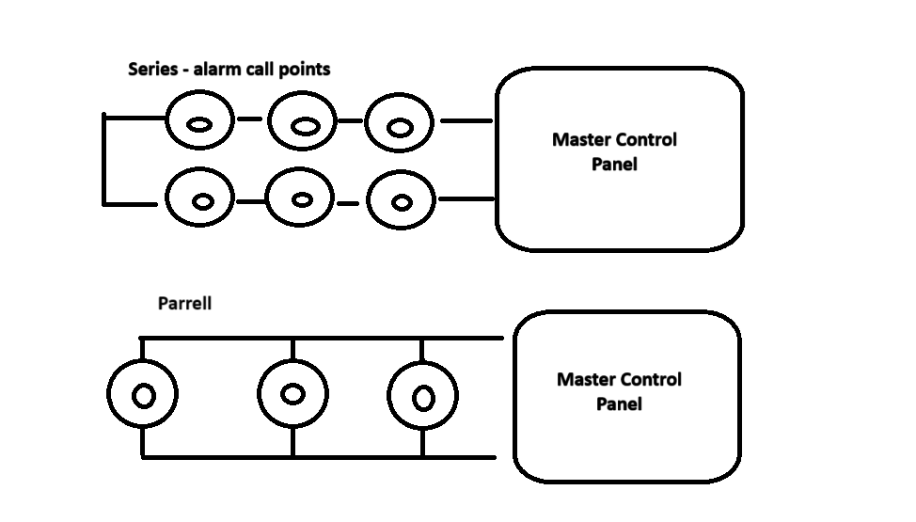

**Alarms protect life and property**

**Types of fire alarm:**

* **Smoke detectors, heat detectors and flame detectors**

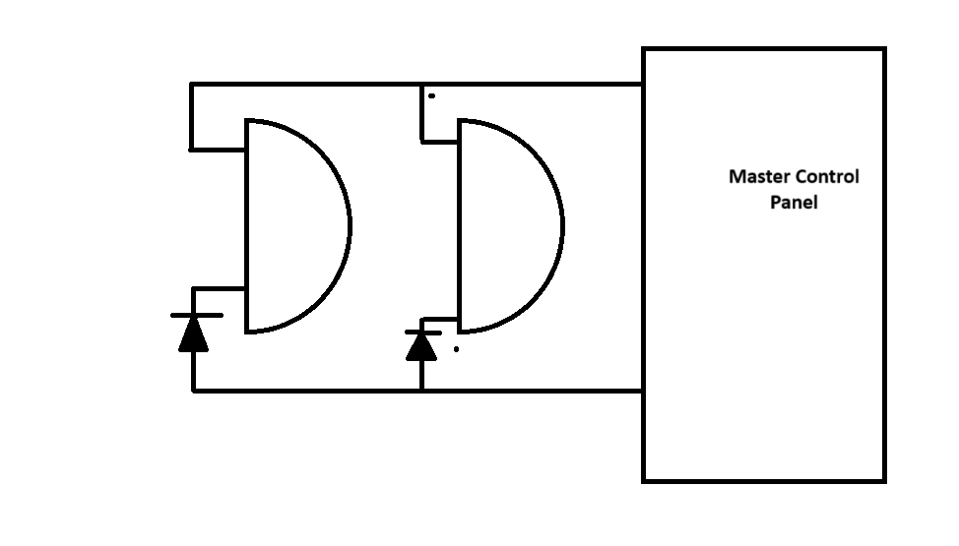

**Two types of circuit inside an interior alarm (Tamper circuit and detector circuit)**

**Emergency lighting**

**- Maintained means it is constantly on**

**- Non-maintained on when incidents occurs**

**Green means the light is charging. Red means battery is unplugged.**

**Emergency lights will need to be wired with a permanent Live so that the emergency light will know when you have a power cut.**

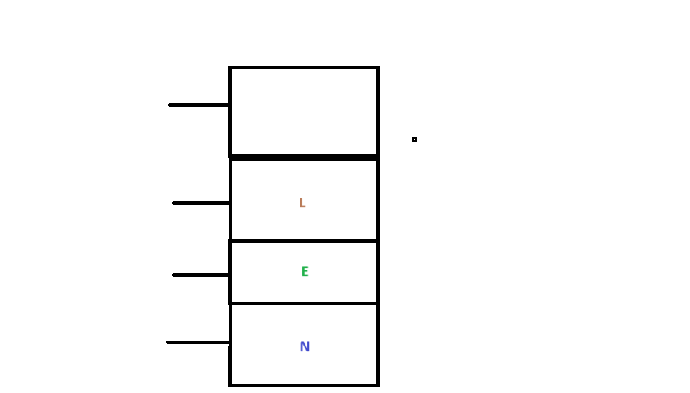

**A spur is a switched fused connection unit with a flex outlet.**

**Underfloor heating is when a thin wire is given a greater current and/or voltage pushed through it. This makes the wire hot and in turn heats the flooring.**

**S plan wiring and Y plan wiring.**

**A Water boiler is essentially a piece of metal in a water cylinder. It works like a kettle. It works on a Radial circuit.**

**In contrast we also have an instantaneous water heater.**

**Data cables are organised into categories. The higher the category the faster the speed of connection.**

**Orange, green and blue**

**(Orange + white), (Green + white) and (Blue + white)**

**Fibre optics cables uses light and it a thing piece of glass.**

**An advantage of fibre optics cables is that you can install it alongside a power cable/tray with no interference or data scramble.**

**But in a traditional data cable (category 6) if it is placed next to a power cable. Due to magnetism (which is one of the three effects of electricity) it can induce a current in the data cable and scramble the data/information inside that data cable.**

**However, this issue is not possible with fibre optics because the data is sent with light.**

**How to install a SWA cable**

**1 – First place the armour gland into the socket. Then insert the cable into the socket via the armour gland. Make sure you have enough slack to play with. Make a groove into the cable so that it is inline with the last thread. Just before the cone on the gland body.**

**2 – Use a junior hacksaw to cut through the sheath (PVC cover). Cut on the mark you made on step one. The purpose is to cut through the PVC cover and make an indentation on the galvanised steel armour wires. You can use tape to ensure that your cut mark is straight.**

**3 – use a knife to strip the sheath away.**

**4 – Then tweak the steel wire armour back and forward until it falls away from the cable.**

**5 – Then cut away the sheath layer one inch from where the first strip was done. Underneath the sheath will be galvanised steel wire armour. Make a spiral motion with the cable to fan out the steel wire in the direction of travel. Place the steel wire onto the clamping cone of the Gland body.**

**6 – Fasten the steel wires onto the clamping cone of the gland body with the gland nut.**

**7 – Then use the SWA shroud to cover all aspects of the steel wire.**

**We use the earth ring in order to earth all of the steel armour wire. The earth ring is also called a banjo.**